C PROGRAMMING MINI PROJECT DOCUMENTATION

1. Title Page
Project Title: Clinic Management System
Student Name: KISHORE SRINATH C V
Register Number: 921724115021
Department: CSD
College Name: SETHU INSTITUTE OF TECHNOLOGY
Course: Programming in C
Guide / Trainer Name: BALAJI B
Submission Date: 26-02-2026

2. Abstract
The Clinic Management System is a simple console-based application developed using the C programming language. The main objective of this project is to manage patient records efficiently in a clinic.
The system allows the user to:
- Add new patient details
- Display all patient records
- Search for a patient by ID
This program uses structures, arrays, loops, and functions to store and manage patient information. It helps reduce manual record-keeping and improves data organization in small clinics.

3. Introduction

Problem Statement
Managing patient records manually in small clinics can be time-consuming and prone to errors. There is a need for a simple computerized system to maintain patient data efficiently.

Why This Project is Useful
- Reduces paperwork
- Organizes patient records
- Enables quick search and retrieval of data

Applications
- Small clinics
- Medical training institutions
- Academic programming practice

4. Objectives
- To understand structured programming concepts
- To use loops and conditional statements
- To work with arrays and functions
- To improve logical thinking and problem-solving skills

5. Tools & Technology
- Programming Language: C
- Compiler: GCC / Turbo C / CodeBlocks
- Platform: Windows / Linux

6. System Requirements

Hardware Requirements
- Basic Computer
- Minimum 4GB RAM

Software Requirements
- C Compiler
- Any IDE / Text Editor

7. Methodology / Algorithm
- Start the program
- Display menu options
- Read user choice
- Perform selected operation:
  - Add Patient
  - Display Patients
  - Search Patient
- Display output
- Repeat until user chooses Exit
- End program

8. Flowchart
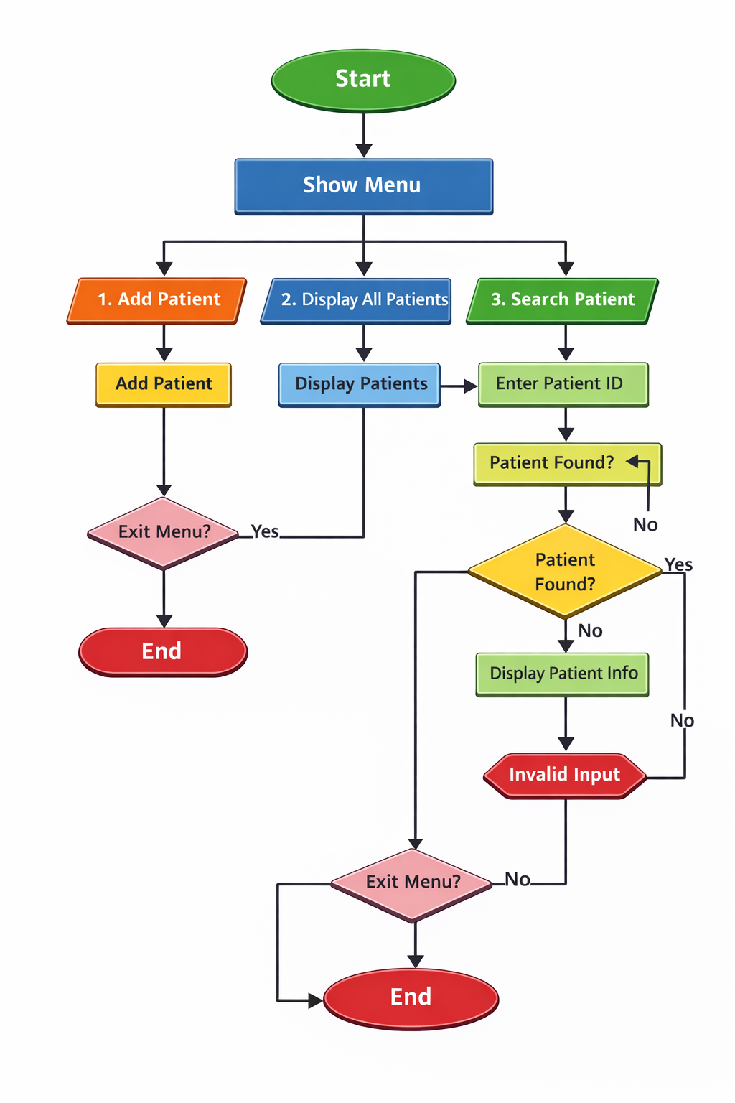

9. Program Code
#include <stdio.h>
#include <string.h>
#define MAX 100
struct Patient {
int id;
char name[50];
int age;
char disease[50];
};
struct Patient patients[MAX];
int count = 0;
void addPatient() {
if (count >= MAX) {
printf("Patient limit reached!\n");
return;
}
printf("\nEnter Patient ID: ");
scanf("%d", &patients[count].id);
printf("Enter Name: ");
scanf(" %[^\n]", patients[count].name);
printf("Enter Age: ");
scanf("%d", &patients[count].age);
printf("Enter Disease: ");
scanf(" %[^\n]", patients[count].disease);
count++;
printf("Patient added successfully!\n");
}
void displayPatients() {
if (count == 0) {
printf("\nNo patient records found.\n");
return;
}
printf("\n--- Patient List ---\n");
for (int i = 0; i < count; i++) {
printf("\nID: %d", patients[i].id);
printf("\nName: %s", patients[i].name);
printf("\nAge: %d", patients[i].age);
printf("\nDisease: %s\n", patients[i].disease);
}
}
void searchPatient() {
int id, found = 0;
printf("\nEnter Patient ID to search: ");
scanf("%d", &id);
for (int i = 0; i < count; i++) {
if (patients[i].id == id) {
printf("\nPatient Found!");
printf("\nName: %s", patients[i].name);
printf("\nAge: %d", patients[i].age);
printf("\nDisease: %s\n", patients[i].disease);
found = 1;
break;
}
}
if (!found) {
printf("Patient not found.\n");
}
}
int main() {
int choice;
do {
printf("\n\n--- Clinic Management System ---\n");
printf("1. Add Patient\n");
printf("2. Display All Patients\n");
printf("3. Search Patient\n");
printf("4. Exit\n");
printf("Enter your choice: ");
scanf("%d", &choice);
switch (choice) {
case 1:
addPatient();
break;
case 2:
displayPatients();
break;
case 3:
searchPatient();
break;
case 4:
printf("Exiting program...\n");
break;
default:
printf("Invalid choice!\n");
}
} while (choice != 4);
return 0;
}

10. Sample Input / Output

Sample Run:
--- Clinic Management System ---
1. Add Patient
2. Display All Patients
3. Search Patient
4. Exit
Enter your choice: 1
Enter Patient ID: 101
Enter Name: Arun
Enter Age: 25
Enter Disease: Fever
Patient added successfully!

Search Example:
Enter Patient ID to search: 101
Patient Found!
Name: Arun
Age: 25
Disease: Fever

11. Result
The program was successfully compiled and executed. It correctly performed operations such as adding, displaying, and searching patient records.

12. Applications
- Learning C programming concepts
- Academic mini-project submission
- Beginner-level clinic record management system

13. Conclusion
The Clinic Management System project demonstrates fundamental concepts of C programming such as structures, arrays, functions, loops, and conditional statements. It provides a basic understanding of how real-world data management systems work.

14. Future Enhancements
- Implement file handling to store data permanently
- Add delete and update options
- Improve user interface
- Add password protection
- Convert to GUI-based application

15. References
- C Programming Textbooks
- Online Tutorials
- Classroom Notes
- GCC Documentation

